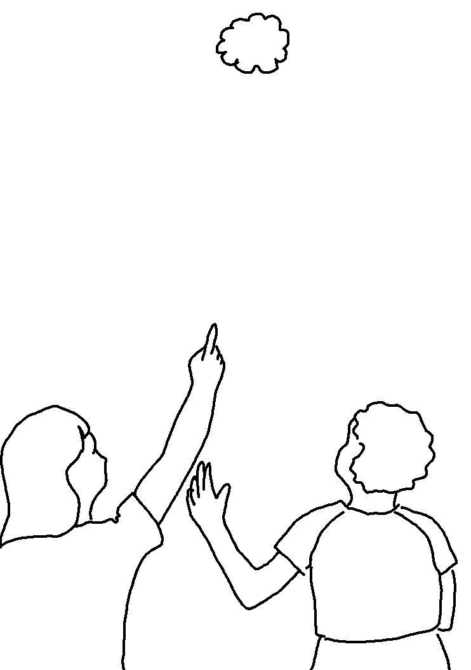
This is our _ _ _; we have waited for Him, and He will _ _ _ _ us.
Isaiah 25:9_{NKJV}

